Ellipta Device Videos in Multiple Languages

QR codes are very easy to use. Simply ask your patients to open the cameras on their phones, and hover over the code. They will automatically be directed to the website in their given language.

Urdu
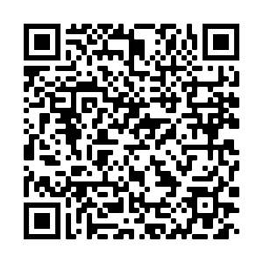

Punjabi
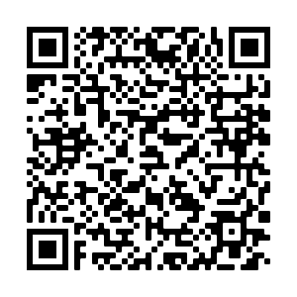

Gujerati
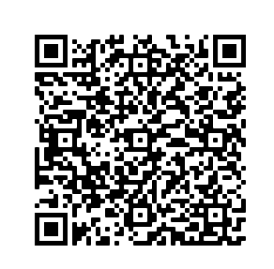

Polish
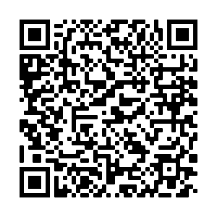

Welsh
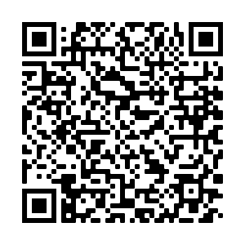

English
Please note that the English inhaler demonstration is not yet hosted on its own website, and will require additional instructions.

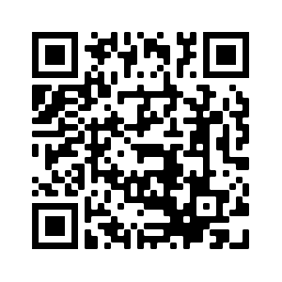

The links to the videos are also to be found here

http://videos.gskstatic.com/pharma/GSKpro/UK/mp4/unbranded-ellipta-how-to-use-video-patient-version-welsh-np-gb-asu-vid-200005.mp4
http://videos.gskstatic.com/pharma/GSKpro/UK/mp4/unbranded-ellipta-how-to-use-video-patient-version-polish-np-gb-asu-vid-200006.mp4
http://videos.gskstatic.com/pharma/GSKpro/UK/mp4/unbranded-ellipta-how-to-use-video-patient-version-punjabi-np-gb-asu-vid-200003.mp4
http://videos.gskstatic.com/pharma/GSKpro/UK/mp4/unbranded-ellipta-how-to-use-video-patient-version-urdu-np-gb-asu-vid-200002.mp4
http://videos.gskstatic.com/pharma/GSKpro/UK/mp4/unbranded-ellipta-how-to-use-video-patient-version-gujarati-np-gb-asu-vid-200004.mp4

