Physiotherapy Advice for Managing Breathlessness and Fatigue post Covid-19 Infection

Breathlessness and fatigue are common symptoms post coronavirus. This advice will help guide your management of these symptoms, and the physiotherapist on the ward can help personalise this to meet your own goals.

Please ask any questions so we can help support you best.

- Now that the acute infection has passed it can feel frustrating to have ongoing symptoms, and you may not feel that your recovery is progressing as well as you thought.
- Breathlessness and fatigue can last for several weeks and, for many, may be an unfamiliar experience.
- Being breathless can be frightening and make you feel uncertain as to the level of activity or exercise to do.

The change to family life and commitments may make it harder to juggle rest:activity over the coming weeks. This can lead to a cycle of boom and bust – overdoing it and then feeling exhausted for several days, feeling a little better and guilty that jobs need to be done, so overdoing it and repeating the cycle. This can bring your mood down and make you feel as if you are making little progress.
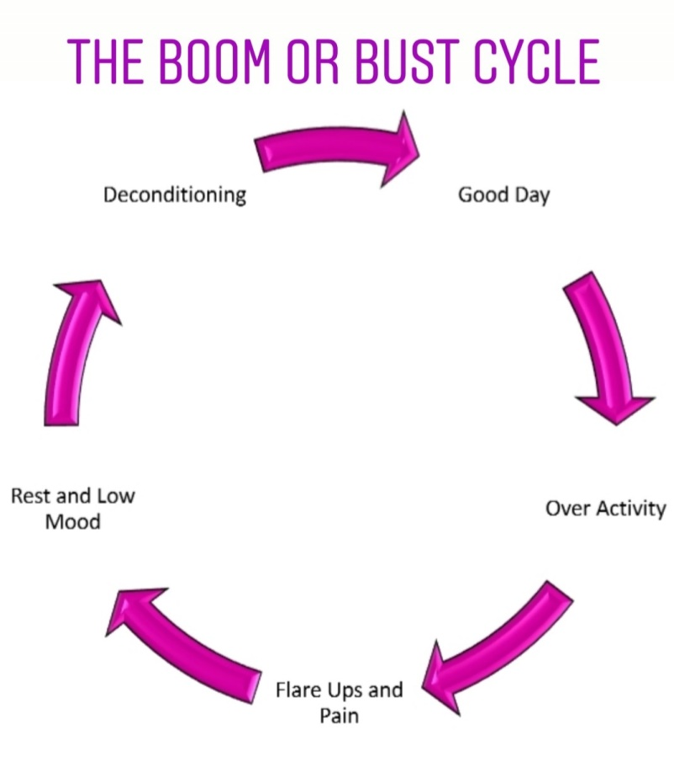
Increased
Fatigue

Please remember;
- Be kind and patient with yourself
- Be as kind and patient with yourself as you would be with others
- Listen to your body and rest when you need

Managing Breathlessness

When recovering from the virus it is common to feel short of breath even after you have returned home. This may include doing everyday tasks such as climbing stairs, getting dressed or during housework.

This can feel very frightening, especially when it is new to you. Having strategies to help manage your breathlessness and bring your breathing under control can help with the anxiety and fear that may come with this.
2. Triangle breathing
1. Positions to help with breathlessness

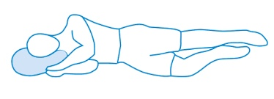
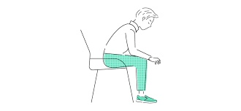

3. Finger Breathing

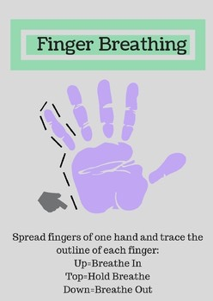
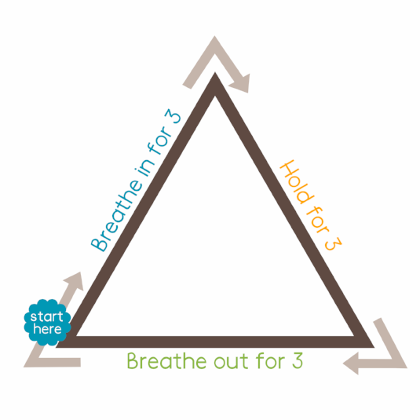
4. Breathing control / Tummy breathing

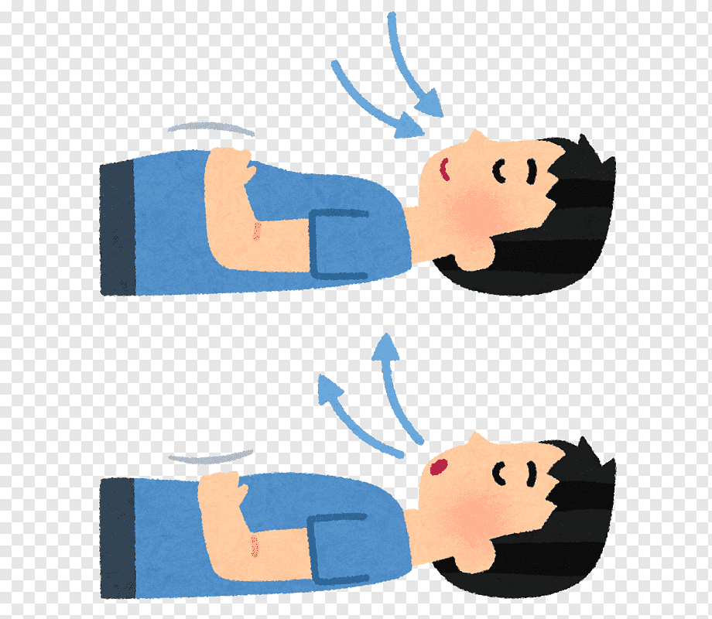

Additional reminders:

Managing Fatigue/Energy Levels

Fatigue can be overwhelming and frustrating when it seems to control what you are able do. Feeling tired and breathless on everyday tasks is not something you may have ever experienced before.

The 3 Ps (Prioritise, Plan and Pace)

- Prioritise – save energy for the things that most need doing. Give yourself time and get into an energy conserving position, such as sitting.

- Plan – what is the best time of day for your energy levels? Can you break the task up into smaller sections? Can you spread these out over the day/week? How can you make the job easier?

- Pace – take frequent breaks to give you a balance between being active and resting. Pacing can help avoid boom:bust patterns.

Be aware of your breathing as you do an activity; try to ensure a steady breathing pattern wherever possible.

Think of your energy like a battery; activity uses it up, rest recharges it. Always leave a little bit in reserve, don’t run it flat.

The Borg Scale (back page) can help with pacing your energy level to keep it at a steady level, between 3 and 4, helping you feel more in control and able to achieve a little bit more.

It may help to keep a diary to identify times of day when fatigue is worse so the physiotherapists or occupational therapists can advise you on alternative management strategies.
Helpful Tips

- Avoid bending and lifting.
- If possible, sit down for activities such as dressing, preparing meals.
- Put a garden chair in the shower and lower the shower head.
- Use bathrobe to dry rather than towel.
- Do only what is important - most things can wait until tomorrow.

Modified Borg Scale for Breathlessness and Effort

Use the Borg Scale below to pace yourself, aiming for the 3 to 4 zone during activity. This will help you to build up your energy levels in the coming weeks.
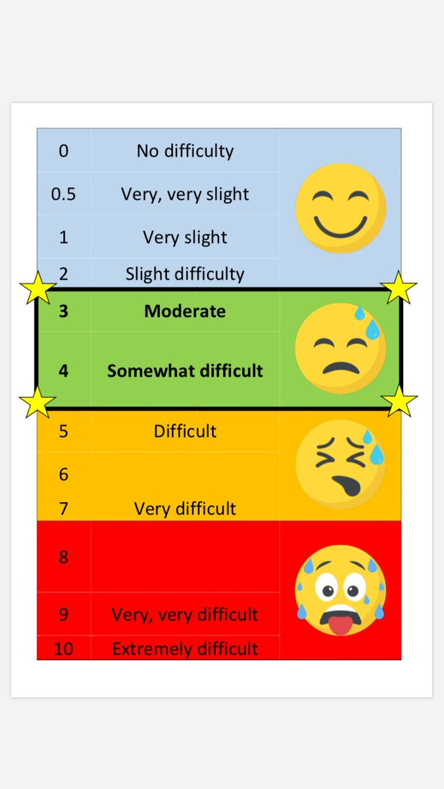
Some useful information sources:

Association of Chartered Physiotherapists in Respiratory Care https://www.acprc.org.uk/publications/patient-information-leaflets/

British Lung Foundation
https://www.blf.org.uk/support-for-you/breathlessness/how-to-manage-breathlessness

Cambridge Breathlessness Intervention Service
https://www.cuh.nhs.uk/breathlessness-intervention-service-bis/resources/patient-information-leaflets

Macmillan Cancer Services
https://www.macmillan.org.uk/cancer-information-and-support/impacts-of-cancer/breathlessness/managing-everyday-life-with-breathlessness

V1 – May 2020
Review – May 2021

